REV. |  | Description |  |  |  |  |  | Date
S00 |  | SPEC ISSUE(NEW MODEL) |  |  |  |  |  | 03/27/2018
S01 |  | 102A-187204  ADD NEW MODEL:ADP-65AE BB |  |  |  |  |  | 07/30/2018
S02 |  | 102A-188031  CHANGE MECHANICAL ITEM.13 |  |  |  |  |  | 08/10/2018
00 |  | 102A-18A075  轉量產 |  |  |  |  |  | 10/15/2018
01 |  | 102A-18A178  ADD ADP-65AE BAA & ADP-65AE BBA |  |  |  |  |  | 11/02/2018
02 |  | 102A-193083  ADD ADP-65AE BC |  |  |  |  |  | 03/12/2019
03 |  | 102A-194172  CHANGE Mechanical characteristics ITEM: 15 |  |  |  |  |  | 04/30/2019
04 |  | 102A-198039  ADD ADP-65AE BD |  |  |  |  |  | 09/02/2019
05 |  | 102A-202053  ADD ADP-65AE BE |  |  |  |  |  | 02/17/2020
06 |  | 102A-208140  ADD ADP-65AE BF |  |  |  |  |  | 09/07/2020
07 |  | 102A-20B103  ADD ADP-65AE BB1 |  |  |  |  |  | 11/18/2020
08 |  | 102A-20C016  ADD ADP-65AE BG |  |  |  |  |  | 12/08/2020
09 |  | 102A-22C059  ADD ADP-65AE BH |  |  |  |  |  | 12/16/2022
10 |  | 102A-23C126  ADD ADP-65AE BA2 |  |  |  |  |  | 12/12/2023
 |  |  |  | 台達電子工業股份有限公司  DELTA ELECTRONICS, INC. |  |  | DESCRIPTION :  電氣規格(Electrical Specification)
 | THESE DRAWINGS AND SPECIFICATIONS ARE THE PROPERTY OF DELTA  ELECTRONICS, INC. AND SHALL NOT BE REPRODUCED OR USED AS THE  BASIS FOR THE MANUFACTURE OR SELL OF APPARATUSES OR DEVICES  WITHOUT PERMISSION. |  |  |  |  |  | MODEL NO. :  ADP-65AE B SERIES
 | Date |  | Drawn |  | Design (EE) | Design (ME) | DOCUMENT NAME. :  ES-65AE B SERIES |  | REV.
 | 12/12/2023 |  | 呂翠娥 |  | 陳新淵/林建銘 | 楊基祥/吳岱洋 |  |  | 10
Frame Name:DF-PSLA4V-2R01.DOC SHEET 2 OF 27

MODEL LIST: ADP-65AE BA/BA2/BAA/BB/BB1/BBA/BC/BD/BE/BF/BG/BH

SCOPE
This document defines the functional requirements for an enclosed 65.0 WATT SINGLE OUTPUT AC-TO-DC ADAPTER intended for worldwide use in Information Technology Equipment. The power supply unit shall be convection cooled. The power supply shall provide an “ADAPTER POWER RATING and ID” signal that communicates the AC Adapter power capability/rating and dynamic power draw from the AC Adapter.

ELECTRICAL

  - INPUT
2.1.1 Voltage
The power supply shall be capable of supplying full rated output power over the input range of 90 to 265 VAC RMS. Nominal voltage is 100-240 VAC. The power supply shall be capable of start-up (power-on) at 90 VAC and 50 Hz minimum.

2.1.2 Power Factor
(For reference only.) The power factor, when measured at 120 VAC and maximum load, shall be greater than 0.5. The source impedance shall be less than 0.1 ohm.

2.1.3 Range Switching
The power supply shall accept the full input range. No range switching is necessary or possible.

2.1.4 frequency
The supply shall operate with an input frequency of 47 – 63 Hz AC. Nominal frequency is
50-60 Hz.

2.1.5 Current
Maximum steady state input current shall be less than 1.7 Amperes RMS at 90 VAC and maximum load.

2.1.6 Input Power Rating
(For reference only.) The supply true input power is less than 80 watts.

2.1.7 Inrush Current
Maximum inrush current, from power-on (with power on at any point on the AC sinewave) and including, but not limited to, three line cycles, shall be limited to a 29% margin of the I2t rating of the input fuse and bridge rectifier:

2.1.7.1 Cold Start
Cool the disconnected power supply long enough to ensure that all components are within 3°C of the minimum temperature as specified in Section 3.1. Apply the maximum input voltage in section 2.1.1 to the power supply.

2.1.7.2 Hot Start
Operate the power supply the maximum ambient operating air temperature as specified in Section 3.1 for 15 minutes. Cycle power to the power supply by removing and reconnecting maximum input voltage as specified in Section 2.1.1.

2.1.8 Protection

2.1.8.1 Under Voltage
The power supply shall not be damaged by applying an input voltage below the minimum specified in Section 2.1.1.
2.1.8.2 Power Line Transient
The power supply shall operate within specifications with the transients defined in IEC
61000-4-4 and IEC 61000-4-5.
The adapter shall survive and the product in which it is installed shall continue to operate
with no component failures during and after repeated applications of the following
transients. In the event that an end use product is not available for these tests, the power
supply shall be loaded at minimum per the load table.
HP recommends that the signal generator be used with low impedance of 12 Ohms.
TABLE 2 POWER LINE TRANSIENT REQUIREMENTS
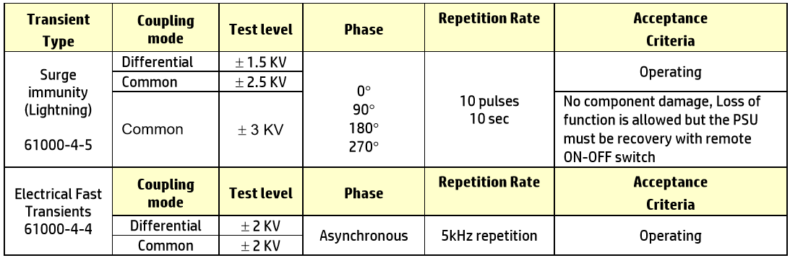
2.1.8.3 Catastrophic Failure Protection
When any single component fails, the power supply will not exhibit any of the following effects:
- Startling noise
- Flame
- Excessive smoke
- Charred PCB
- Fused PCB conductor
- Dielectric breakdown

2.1.8.4 AC Leakage Current
Class I Equipment (Grounded Equipment)
The total combined leakage current when measure in accordance with IEC 60950, 3rd Edition shall not exceed 30 microamperes when tested at 250 VAC, 50 Hz in a normal operating condition.

2.1.8.5 Primary to Secondary Ground
The power supply shall have a 1 Meg Ohm 1/4W resistor and 0.1uF/100V capacitor parallel combination between earth ground (FG) and secondary DC ground.

2.1.8.6 Common Mode Noise
The common mode noise when measure in accordance with IEC 62684 shall not exceed
follow below requirement
The peak-to-peak voltage measured in the frequency range of 10KHz to 100KHz
shall not exceed 1V peak-to-peak.
The peak-to-peak voltage measured in the frequency range of 100KHz to
400KHz shall not exceed 200mV peak-to-peak.

2.1.8.7 ISN resistors:
The power supply shall have a 470 Ohm(minimum) resistor between earth ground(FG)
and secondary DC ground.

2.1.9 Energy Efficiency
The device shall conform to the EPA Energy Star Requirements Level VI for External Power Supplies

          - The Average Active Mode Efficiency minimum (Calculated but testing at 100%, 75%,
50% and 25% of rated output power and then computing the average of these four
values) must be greater than 88% at 115Vac input and 89% at 230Vac input.
          - In addition the device must meet the No Load/Light Load requirements as specified below (measured at 115Vac/60Hz and 230Vac/50Hz):

No Load/Light Load
Output Load | Maximum Input Power
0W | 0.15W
0.25W | 0.5W
0.5W | 1.0W
1.0W | 1.7W
1.5W | 2.4W

2.2 OUTPUT

2.2.1 Voltage
One (1) output shall be provided as defined and measured at the output connector of the supply:
Output Voltage: 19.50V +5.0%/-5.0%

2.2.2 Current
Min Load 0A
Nom Load 1.7A
Max Load 3.33A
Peak Load: 5.0A/300ms max
Peak Load: 6.0A/10ms max – 2.4A peak to 6.0A
Note: the output voltage will be allowed to drop to 15V minimum during this transient (measured at 100Vac).
3.49A/3 minutes
3.7A/1 minute
3.81A/30 seconds

2.2.3 Power
The power supply shall be capable of continuously supplying, when installed in the end use system, 65 Watts under all specified conditions.

2.2.4 Adapter Power Rating and ID
The power supply shall provide an “ADAPTER POWER RATING and ID” signal proportional to the output load current and output power rating power of 65 Watts. This signal communicates the AC Adapter power capability/rating and dynamic power draw from the AC Adapter. There shall be provisions to adjust the tolerance of the Power Rating. This signal should provide:

- A 383 KOhm between the output voltage and the ID pin.
- A high level current source between 3.15A to 3.49A available at the ID pin.
- At start-up when the output voltage is within its steady-state tolerance and at its rated load, or when the output current reaches 20% above its rated current, the “ADAPTER POWER RATING” signal shall start to become active after a delay of 50ms to 300ms.

2.2.5 Transient Response
(Step Load) The following transient loads are to be applied to the output. The frequency range of the transient loads described shall be from 1 Hz to 5 kHz. The waveform shall be a square wave with the slope of the rise and fall at 1 A/microsecond. The output voltage tolerance shall be allowed ± 5% during a step load change of up to 90% of full load including steps increasing from standby load or decreasing from full load. Varnishing or vacuum impregnation is required. Measurements should be made at output cable connector.

2.2.6 Output Regulation
At nominal input line voltage (120Vac), the output shall be subjected to the load described in Section 2.2.2, and shall remain within the regulation limits as defined in Section 2.2.1.

2.2.7 Protection
The power supply shall automatically shutdown under the conditions described below.

2.2.8 Over Voltage
The power supply shall provide over voltage protection such that under any single component failure, the output channel shall not exceed 29 volts with a maximum duration of 250 milliseconds.

2.2.9 Over Current
The power supply shall limit the maximum steady state output current (Steady state > 1 Second) to an average current of 11 Amperes.

2.2.10 Short Circuit
The power supply shall be protected such that a short from output to return shall not result in a fire hazard, shock hazard, or damage to the power supply.

2.2.11 Outputs/Ripple/Noise
Maximum allowable peak-to-peak ripple and noise (as measured at the load with 100VAC input) on the output channel shall be 380mV pk-pk (or 250 mV RMS) ripple within 10 kHz to 20 MHz bandwidth. A resistive load (non-electronic) shall be used for this measurement. The output shall be bypassed to return by 1.0 microfarad ceramic capacitor in parallel with
10 microfarad tantalum capacitor at the point of load. The load cable shall be the specified output cable assembly. The printed wiring board assembly shall be installed in its enclosure for this measurement or have the measurement leads properly shielded and proper earth grounds applied to power supply.

2.2.12 Stability
The power supply shall be unconditionally stable while operating within its normal operating specification.

2.2.13 Overshoot
During power-on or power-off, the output voltage shall be monotonically increasing or decreasing with respect to the overshoot which shall neither exceed 21 volts peak nor be outside the regulation requirements for more than 10 milliseconds (mS).

2.2.14 Power-On Time
Output Regulation: The output shall be in regulation within five (5) seconds after valid input power (90 VAC) has been applied.

2.2.15 Acoustic Noise
The power supply when tested in an anechoic chamber shall not exceed the sound pressure levels per the HP AC Adapter Acoustic Noise Test Specification under all output load and ac input conditions. Acoustic noise measurements shall be conducted under accordance with ISO 7779 (or ECMA-74) and declared in accordance with ISO 9269 (or ECMA-109).

2.2.16 Hold Up
The power supply shall maintain voltage regulation within the specified limits in paragraph 2.2.1 for at least 5 milliseconds after loss of input voltage measured at 115 VAC and at maximum load.
[Option] The power supply shall maintain voltage regulation within the specified limits in paragraph 4.2.1 for at least 10 milliseconds after loss of input voltage measured at 115 VAC and at 80% load.

2.2.17 System Capacitive Load
The system load capacitance is 2200uF. Plugging a live AC Adapter into the system capacitance shall not cause the adapter to shut down.

2.2.18 Thermal Shutdown
The power supply shall incorporate over temperature protection to prevent catastrophic failure from overheating.

2.2.19 Rise Time
Output Voltage: The output shall be in regulation within 40mS at 0A to 500mA condition.
(Measured from 10% to 95% regulation)

3. ENVIRONMENTAL REQUIREMENTS

3.1 TEMPERATURE

3.1.1 Operating
The supply shall operate from 0 to 35°C. The maximum temperature rise of any surface shall not exceed 45°C when measured at 100 VAC and at maximum load.

3.1.2 Non-Operating
The power supply can be stored from -20 to 85°C.

3.2 COOLING
The power supply shall be convection cooled only.

3.3 HUMIDITY
The power supply shall withstand without degradation with 95% relative humidity, non-condensing, both operating and non-operating.

3.4 ALTITUDE

3.4.1 Operating
The power supply can be operated at 10,000 feet above sea level.

3.4.2 Non-Operating
50,000 feet above sea level.

3.5 MECHANICAL SHOCK
(Power supply inside assembly.)

3.5.1 Operating
10 G, 11 ms, half sine, one shock input in each of three mutually perpendicular axes, for a total of six shock inputs.

3.5.2 Non-Operating
100 G peak, trapezoid, 180 in/s velocity change, one shock input per direction in each of three mutually perpendicular axes, for a total of six shock inputs. 240 G peak, 2 ms, half sine, one shock input in each of three mutually perpendicular axes, for a total of six shock inputs.

3.5.3 UL Safety
36-inch drop onto hardwood surface, after which no safety hazard is encountered regardless of operational capabilities.

3.5.4 Shipping
42-inch drop, all edges, surfaces - while enclosed in appropriate shipping container.

3.6 VIBRATION
(Supply inside assembly.)

3.6.1 Operating
0.75 G zero to peak, 5 to 500 Hz, 0.5 octaves/minute, one cycle, 5 to 500 to 5 Hz per axis in each of three mutually perpendicular axes.

3.6.2 Non-Operating
1.5 G zero to peak, 5 to 500 Hz, 0.5 octaves/minute, one cycle, 5 to 500 to 5 Hz per axis in each of three mutually perpendicular axes.

0.025 G squared/Hz, 10 to 500 Hz, nominal 3.5 G RMS level, one hour per axis, in each of three mutually perpendicular axes for a total duration of three hours.

3.7 ELECTROSTATIC DISCHARGE (ESD)
The AC adapter shall withstand ESD test voltage conditions at any point on the enclosure using the test setups and conditions found in Document 131296 and with transients as defined in IEC 801-2. As an infrequently user touchable subassembly, the following test levels shall be used:
- After Air discharge ±15KV and Contact discharge ±8KV, adapter is no allowed error and damage.
- After Air discharge ±20KV, need report result.

The storage capacitance shall be 150 pF and the discharge resistance shall be 330 ohms.

3.8 European Union Directive 2002/95/EC – Rohs directive
The AC Adapter shall comply with the RoHS directive specified in the hp GSE, document #
HX-00011-00 and HP General Requirements for Supplier Compliance with the RoHS Legislation, document # EL-MF867-00. The AC Adapter label must also bear the “WEEE” logo.

The supplier’s version of Declaration of Conformance must demonstrate restricted materials comply with HP GSE/RoHS threshold limits.

3.9 EMC REQUIREMENTS AND APPROVALS
The information contained in this section is/was the criteria and approvals anticipated at the time of release of this document. This information may not be current. It is suggested that for current information, the Hewlett-Packard EMC Services group be contacted.

Based upon the intended marketing and use of the product, the AC Adapter shall comply with:

C.I.S.P.R. REQUIREMENTS: All administrative and performance requirements for C.I.S.P.R. Publication 22 Class B. Radiated emission testing shall be performed at 10 meters. Conducted emission testing shall be performed at the rated line voltages. This device, when tested as part of a system defined by Hewlett-Packard, shall not increase the emissive level of that system to a level greater than 3 dB below the class B limits. Testing shall be performed using Hewlett-Packard labeled/manufactured peripherals.

AUSTRALIAN ACMA APPROVAL: All administrative and performance requirements for AS/NZS

, class B in accordance with the Electromagnetic Compatibility Framework Information for Suppliers document, July 1995 and URL: http://www.acma.gov.au/ . The product label shall contain the C-Tick logo and the manufacturer’s Supplier Code. Use of an agent is required.

TAIWAN BSMI APPROVAL: All administrative and performance requirements for the BSMI Taiwan "Commodity EMC Regulation" in accordance with Chinese National Standard (CNS) 13438 (CISPR 22), class B and URL: http://www.bsmi.gov.tw . The product label shall contain the BSMI ID number. The BSMI certificate must include both the Hewlett-Packard (HP) series number and the marketing name.

3.10 HARMONIC CURRENT EMISSIONS
N/A

3.11 VOLTAGE FLUCTUATIONS FLICKER REQUIREMENTS
The power supply shall comply with the applicable limits for voltage fluctuations and flicker in IEC 61000-3-3 when tested under all conditions of varying load exhibited by the intended Hewlett-Packard product for which the power supply is to be used. The OEM shall provide Hewlett-Packard’s Agency group with a copy of the test report showing all applicable measurements.

3.12 IMMUNITY REQUIREMENTS
The AC Adapter shall comply with the following requirements and associated test parameters:

- Electrical Product Safety requirements…………………………….IEC 60950-1, 2nd Ed, 2005-12
- EMC compliance requirements EN55022 (CISPR 32 - Class B at 10 meters)
- Harmonic distortion compliance requirements EN 1000-3-2
- Line voltage fluctuation and flicker requirements EN 1000-3-3
- Immunity compliance requirements EN55024 consisting of:

- IEC 61000-4-2: 1995 Electrostatic Discharge [4kV contact, 8kV air discharge]
- IEC 61000-4-3: 1995 RF Fields [3V/m; 80 - 1000 MHz; 80% modulated
at distance of 3 meters]
- IEC 61000-4-4: 1995 Elec. Fast Transients [± 1kV on AC power port for
1 minute;±0.5kV on signal/control lines]
- IEC 61000-4-5: 1995 Surge [± 1kV line to line/±2kV line to earth on AC
power port; ±0.5kV for outdoor cables]
- IEC 61000-4-6:1996 Conducted RF [3V; 0.15-80MHz; 80% modulated]
- IEC 61000-4-11:1994 Voltage variations [>95% dip,0.5 period; 30% dip,
25 periods;>95% reduction, 250 periods]
For the purposes of compliance with EN 55024, the product when tested with the intended Hewlett-Packard system, shall not cause a halt of the operation of software applications operating on the Hewlett-Packard. Voltages and currents shall remain within the specified parameters contained elsewhere in this document. Test setups shall be in accordance with EN 55022, namely complete systems with all ports appropriately terminated into a peripheral.

- The manufacturer shall place the “CE Mark” on the AC Adapter.
- Manufacturer’s Declaration of Conformity - A DofC accompanied by a complete Technical Data file containing all associated Test Reports shall be provided to the Hewlett-Packard EMC Services and Product Safety groups prior to first revenueable product shipment.

All EMC testing/submissions shall be performed using the most recent operating systems software appropriate for the product (e.g., Windows 95), Hewlett-Packard labeled/manufactured peripherals, the defined test systems (contact EMC Services), and a continuous scrolling 'H' pattern.

3.13 Agency Acceptance Testing
Acceptance testing will be performed by Hewlett-Packard. Test samples for acceptance testing will be retained by Hewlett-Packard.

Copies of all submissions documents and resulting approvals will be supplied to Hewlett-Packard' Product Safety and EMC Services representatives prior to first revenueable product shipment.

3.14 Production Line Test Compliance
(For Class I Grounded Units) As part of our end product Production Line Tests, Hewlett-Packard reserves the right to conduct the Hipot and Ground Bond Tests with the associated test parameters as noted below on the AC Adapter production. Failure to comply with the Hewlett-Packard end product Hipot or Ground Bond tests when conducted at Hewlett-Packard is considered unacceptable and a justification for rejection. In addition to meeting the minimum UL/CSA/TUV production line tests, the OEM AC Adapter manufacturer may opt to change the production parameters provided the OEM accepts responsibility for conformance with the Hewlett-Packard Production test parameters.

3.15 Production Line Hipot Test
One hundred percent (100%) of the AC Adapter shall comply with the minimum Production Line Hipot (High Potential) Test as noted below. The test shall be applied between the PRIMARY (AC LINE and NEUTRAL) to Secondary GROUND(Vo and GND).

PARAMETERS | SETTING
VOLTAGE | 3000Vac Minimum
TRIP CURRENT SENSITIVITY | 600 Microamperes Maximum
VOLTAGE RAMP TIME | 500 V/Second ramp Minimum
DWELL TIME | 1 Second Minimum
BREAKDOWN ARC DETECTION | 10 Microseconds Maximum

note:
The ROD-L DC Hipot Tester Model M100DC can be set to comply to the above test parameters.

3.16 Production Line Ground Bond Test
One hundred percent (100%) of the OEM AC Adapter shall comply with the minimum Production Line Ground Bond Test as noted below. The test shall be applied between the ACCESSIBLE SHEET METAL CHASSIS and the INPUT RECEPTACLE EARTH GROUND TERMINAL prior to welding the plastic enclosures.

PARAMETERS | SETTING
OUTPUT CURRENT | 25 Amperes Minimum
OUTPUT VOLTAGE | 2.5 VAC or Vdc Minimum
TRIP RESISTANCE SENSITIVITY | 0.1 Ohms Maximum

note:
The ROD-L DC Ground Continuity Tester Model M25 can be set to comply to the above test parameters.
3.17 AGENCY COMPONENT REQUIREMENTS

3.17.1 Printed Wiring Boards

3.17.1.1 Safety
All printed wiring boards shall be Underwriter Laboratories Inc. Recognized Component rated 94V-1 or less flammable and shall be so marked. The maximum board surface temperature shall not exceed its UL temperature rating under any normal operating condition. Use of solder build-up on traces as a method of increasing current/energy capacity shall be approved by each of the Agencies identified in Section 6.

3.17.1.2 Solder Mask
Solder mask shall be provided on all primary and secondary traces with spacing less than 2 mm.

3.17.2 Wiring
All internal wiring shall be UL Recognized Component Appliance Wiring Material (AVLV2), and CSA Certified “Appliance Wiring Material” (AWM). Wire shall be minimum rated 300 V, 105°C.

3.17.3 AC Line Fuse
The AC Line Fuse shall be per Standard Sheet 1 of IEC 60127. The PWB shall be marked with the fuse voltage and current.

3.17.4 AC Receptacle
The Inlet receptacle shall comply with IEC 60320 Standard sheet C6 and be Certified, Recognized or approved by CSA, UL, VDE and one of the Nordic Agencies (NEMKO, SEMKO, FIMKO, DEMKO). Each appliance inlet pin shall be able to withstand a 15 lb. force applied perpendicularly to its axis; the force shall be applied within 1.5 mm of the tip of the pin without breaking. Otto Heil part number 2562-01 and Inalways part number 0724-FP2 are approved.
Solid pins must be used.

3.18 E-Caps life time
• All Aluminum electrolytic capacitors shall have a minimum lifetime of 8,736 hours at
ambient temperature of 35degC and 80% load.
• Usage profile 8h x 52 weeks x 3 yrs = 8,736 hours

Mechanical characteristics
 | Item | Conditions |  |  |  |  |  |  |  |  | Specification
1. | Bending test | Bead core - DC cord
1. | Bending test | Load | Angle (θ) |  | Arbitrary  direction |  | Cycles in every minute |  | Sample size
1. | Bending test | 200 g | ±90° |  | 5000 Cycle |  | 40 Cycles |  | 5 Pcs |  | Disconnection rate of the wire shall be 30% or less, without damage to the insulations, etc..
1. | Bending test | DC plug over mold
1. | Bending test | Load |  | Angle (θ) |  | Arbitrary  direction |  | Cycles in every minute |  | Sample size
1. | Bending test | 200 g |  | ±180° |  | 1000 Cycle |  | 40 Cycles |  | 5 Pcs | Disconnection rate of the wire shall be 10% or less, without damage to the insulations, etc..
1. | Bending test | 200 g |  | ±180° |  | 5000 Cycle |  | 40 Cycles |  | 5 Pcs | Disconnection rate of the wire shall be 50% or less, without damage to the insulations, etc..
1. | Bending test | 200 g |  | ±180° |  | Until broken |  | 40 Cycles |  | 5 Pcs
1. | Bending test | Case SR
1. | Bending test | Load |  | Angle (θ) |  | Arbitrary  direction |  | Cycles in every minute |  | Sample size
1. | Bending test | 200 g |  | ±180° |  | 1000 Cycle |  | 40 Cycles |  | 5 Pcs | Disconnection rate of the wire shall be 20% or less, without damage to the insulations, etc..
1. | Bending test | 200 g |  | ±180° |  | 5000 Cycle |  | 40 Cycles |  | 5 Pcs | Disconnection rate of the wire shall be 100% or less, without damage to the insulations, etc..
1. | Bending test | 200 g |  | ±180° |  | Until broken |  | 40 Cycles |  | 5 Pcs
1. | Bending test | The test sample is hung by specified weight.  It shall be bent through angles of specified degrees in one direction, returned to its original position, then bent specified degrees in the opposite direction, after which it shall be returned to its original position to complete one cycle.  The rate flexing shall be specified cycle per min.
Item |  | Conditions |  |  |  |  |  |  |  |  | Specification
2. | Winding test | Only for horizontal side. 纏繞線材需完整的繞在CASE上  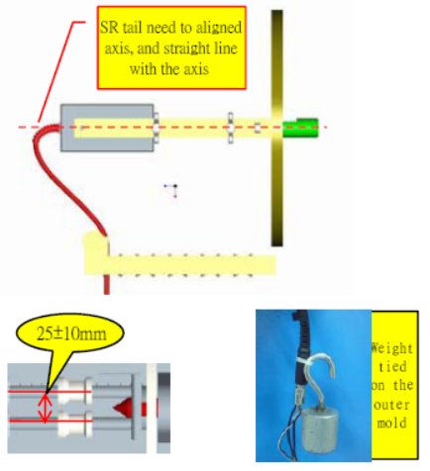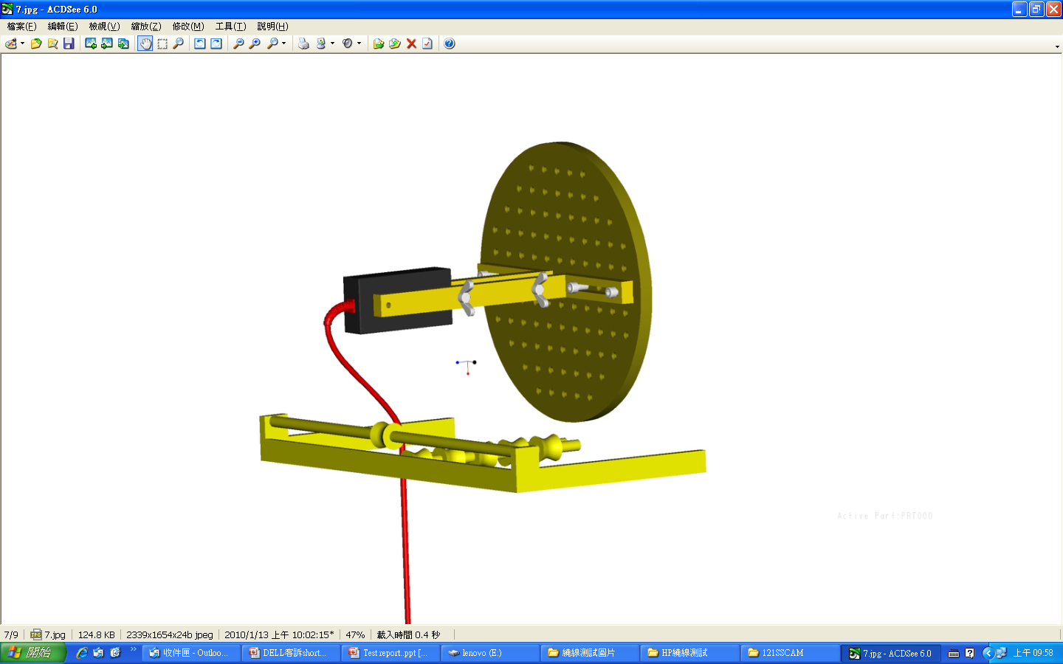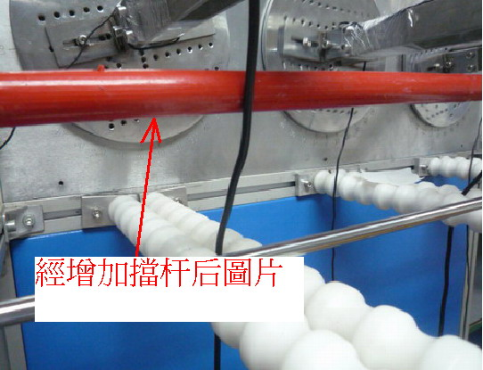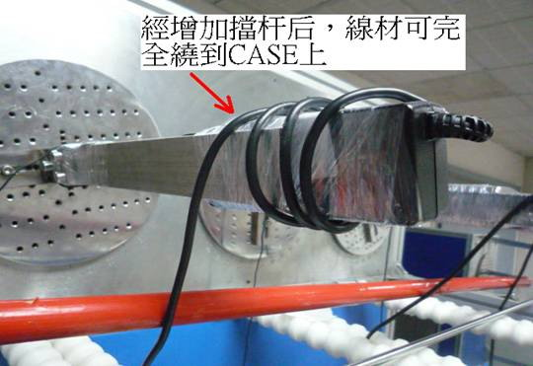  Winding Test SOP  1. Base on Test Condition to set up winding machine  ( for example frequency, the numbers and laps etc...).  2. Block width (25±10mm) Debugging machine. Then tested the cable tail.  3. PLUG out mold side going to bend and tie it up, then follow hang weights request to hanging to the out mold.  4. Make sure winding setting parameters, after confirm then going winding test.  5. After finish winding test，remove cable and dissection step by step. |  |  |  |  |  |  |  |  | Disconnection rate of the wire shall be 50% or less, without damage to the insulations, etc..
  Load | Angle (θ) | Arbitrary  direction | Cycles in every  minute | Sample size
  200 g | +/-1080° | 4000 Cycle | 2 Cycle | 3 Pcs
3. | Vibration | Only endurance conditioning by sweeping shall be made.  Operating  0.75 G zero to peak, 5 to 500 Hz, 0.5 octaves/minute, one cycle,  5 to 500 to 5 Hz per axis in each of three mutually perpendicular axes.  Non-Operating  1.5 G zero to peak, 5 to 500 Hz, 0.5 octaves/minute, one cycle, 5 to 500 to 5 Hz per axis in each of three mutually perpendicular axes.  0.025 G squared/Hz, 10 to 500 Hz, nominal 3.5 G RMS level, one hour per axis, in each of three mutually perpendicular axes for a total duration of three hours. |  |  |  |  |  |  |  |  | Output voltage ± 0.5V.
3. | Vibration |  |  |  |  |  |  |  |  |  | Dielectric strength：Without ignition smoke, damage, arcing or breakdown.
3. | Vibration |  |  |  |  |  |  |  |  |  | Insulation resistance ：100MΩ or more
3. | Vibration |  |  |  |  |  |  |  |  |  | Appearance：There shall be no blistering of the specification label or other damage to the construction.
4. | Shock | Operating  10 G, 11 ms, half sine, one shock input in each of three mutually perpendicular axes, for a total of six shock inputs.  Non-Operating  100 G peak, trapezoid, 180 in/s velocity change, one shock input per direction in each of three mutually perpendicular axes, for a total of six shock inputs.  240 G peak, 2 ms, half sine, one shock input in each of three mutually perpendicular axes, for a total of six shock inputs. |  |  |  |  |  |  |  |  | Output voltage ± 0.5V
4. | Shock |  |  |  |  |  |  |  |  |  | Dielectric strength：Without ignition smoke, damage, arcing or breakdown.
4. | Shock |  |  |  |  |  |  |  |  |  | Insulation resistance：100MΩ or more.
4. | Shock |  |  |  |  |  |  |  |  |  | Appearance：There shall be no blistering of the specification label or other damage to the construction.
5. | Drop test | Delta Drop Test Standard for Portable Power Supply  Test height：1 meter for every surface (6 sides) 1 times  Test surface material：hardwood surface or concrete |  |  |  |  |  |  |  |  | 1. Electrical characteristic  shall be satisfied.  2. PWB 銅箔無掀起或傷害  3. 無銲錫破損  4. 無零件破損  5. 若測試造成外殼  (Enclosure)裂縫,必須  Repeat test 5 times. 並進行root cause analysis and provide corrective action.  6.測試Hi-pot為”PASS”  時,產品若有破洞, 裂縫  時需檢查User  accessible area與  Hazardous voltage  parts,必須keep Double  or Reinforced  insulation.
6. | AC inlet insertion and withdrawal | DENAN-LAW：Rated load 5000 times, and rated load 1.5 folds/100 times (20 times/min.)  UL/CSA：Rated load 1.5 folds/250 times (10 times/min)  IEC：Rated load 1000 times, and without rated load 3000 times  (15 times/min.) |  |  |  |  |  |  |  |  | Without distinct damage in appearance.  Electrical characteristic shall be satisfied.
7. | AC inlet weight test | The plug shall be connected to AC inlet then direction of plug X and Y shall be applied to there condition.  Weight: 100 N. Time: 5 sec.  Test times: 3 times. |  |  |  |  |  |  |  |  | Without distinct damage in appearance.  Electrical characteristic shall be satisfied without solder crack of mounted board on AC inlet
8. | Ball impact | Delta Impact Test Standard for Portable Power Supply  1 The sample is placed on the laminated wood surface with the surface to be impacted positioned horizontally. If the sample needs to be stabilized or held in place, the stabilizing device must be solid to allow for the intended force to be delivered to the sample. For example, if blocks are used to support the samples, the blocks shall be secured together so that the sample sits securely and doesn’t move due to the impact delivered by the steel ball. The sample must be in contact with the laminated wood surface at all times.  2 The steel ball is allowed to fall freely from rest through the guide tube for a vertical distance of 1.3M to the point of impact.  3 Only one impact per sample shall be made. Use new samples for additional impacts. |  |  |  |  |  |  |  |  | 1. 若測試造成外殼  (Enclosure) 裂縫,必須  Repeat test 5 times. 並  進行root cause analysis  and provide corrective  action.  2. 測試Hi-pot為”PASS”  時,產品若有破洞, 裂縫  時需檢查User  Accessible area與  Hazardous voltage  parts,必須keep  Double or Reinforced  insulation.
9. | Acoustic Noise | Measurements to determine the AC adapter sound pressure are made using a 1/2” low noise free-field microphone in a inner size with 45(W)×45(D)×65(H) cm^3 Anechoic chamber. |  |  |  |  |  |  |  |  | Delta Spec.:  The AC Adapter shall produce no human perceivable audible noise (less then 25dB)  No load：< 22dB  0~Full Load:： 25dB
9. | Acoustic Noise | Position the microphone ten (10) centimeters above the x-y center of the AC Adapter.  Allow the AC adapter to warm-up for a minimum of 30 minutes prior to starting the test  Take a measurement with the AC Adapter configured for each of the test cases below:  No Load - 120Vac/60Hz  No Load - 240Vac/50Hz  Nominal Load - 120Vac/60Hz  Nominal Load - 240Vac/50Hz  Maximum Load - 120Vac/60Hz  Maximum Load - 240Vac/50Hz  10% Load -120Vac/60HZ  10% Load -240Vac/50HZ  Table – AC Adapter Acoustic Noise Levels |  |  |  |  |  |  |  |  | Pass/Fail Criteria  Please refer to the Table
  Frequency  (Hz) | Mag dBA  re 20 µPA |  | Frequency  (Hz) | Mag dBA  re 20 µPA
  630 | 5.0 |  | 4.00 k | 12.0
  800 | 7.5 |  | 5.00 k | 11.0
  1 k | 9.0 |  | 6.30 k | 10.0
  1.25 k | 12.0 |  | 8.00 k | 9.0
  1.6 k | 11.0 |  | 10.00 k | 8.0
  2.0 k | 12.0 |  | 12.50 k | 7.5
  2.50 k | 12.0 |  | 16.00 k | 13.0
  3.15 k | 12.0 |  | 20.00 k | 20.0
10. | Adhesion of specification labels | 1. Tape peeling test  2. High temperature storage  The AC adaptor shall be stored at a temperature of 65 ± 2℃  with relative humidity of 90% to 95% for 6 to 7 h  3. Low temperature storage  The d. c. power supply shall be stored at a temperature of -20 ± 3℃ for 6 to 7 h. |  |  |  |  |  |  |  |  | There shall be no blistering or peeling of the specification label.
11. | Wiggle test | 1. Fasten adapter and cord firmly to their plates.  2. Adjust motor cam shaft so that AC adapter is in max forward position.  3. Connect cord to AC power and adapter output cable to DC load with LED to indicate that power is on.  4. Adjust plate distance so that adapter and cord just make connection and LED is lit.  5. Adjust DC load to maximum load for adapter (65W adapter = 3.75A).  6. Let adapter thermally soak for 15-20 minutes.  7. Adjust Variac to ~30VAC (~750RPM) and run for ~10 minutes.  8. Adjust Variac to ~0VAC and adjust motor cam shaft so that AC adapter is in max forward position.  9. Adjust plate distance so that adapter and cord just make connection and LED is lit.  10. Repeat steps 7 through 9 until adapter receptacle contacts begin to produce audible arcing noises.  11. Repeat steps 6 through 9 except lower Variac operational voltage to ~20VAC (~300RPM) until adapter begins to produce consistently long or loud popping and arcing noises.  12. Remove adapter and plug from plates and attempt to manually twist cord slightly while varying the insertion distance, attempting to  produce prolonged arcing, If manual manipulation should begin to prove unproductive, return to fixture and repeat step 11.  13. There is a "test to failure" pass criteria. This means continue to  execute this test procedure until the adapter no longer conducts or the test ends in smoke or melting. |  |  |  |  |  |  |  |  | 1. 如過程中有發煙,熔毀,  停止後將樣品外殼拆開,  觀察SOCKET後方如果  Pin鉚接處沒有晃動, 可  判定為 ”PASS”, 如  SOCKET後方零件有被  燒毀的現象,則判定為  ” FAIL”  2. 請注意鉚接處發黑不是  指塑膠熔毀後,覆蓋於鉚  接處的現象
Item |  | Conditions |  |  |  |  |  |  |  |  | Specification
12 | Outline dimension  Case Color | 90 x 51 x 28.5, BLACK |  |  |  |  |  |  |  |  | L x W x H, Color
13 | Weight | 185±10g |  |  |  |  |  |  |  |  | XX g
14 | AC Inlet | C6 |  |  |  |  |  |  |  |  | C6 or C8 or C14 or CX Type
15 | DC Connector |  |  |  |  |  |  |  |  |  | X Type  O.D. x I.D. x L
  ADP-65AE BA/BAA/BD/BH | ADP-65AE BB/BBA/BC/BE/BF/BG
  BARREL Type | BARREL Type
  4.5 x 0.6 x 12 | 7.4 x 0.6 x 12.5
16 | DC Cable Length | 1800 |  |  |  |  |  |  |  |  | XXXX mm
17 | 測試DC JACK型號 | FOXCONN JPDD4C-C57GP0B-4H,  SU YIN DFPJ-05MR042-XW2或同等品

Product Application: Notebook (FOR ADP-65AE BA/BAA/BB/BBA/BH)
Monitor (FOR ADP-65AE BC/BF/BG)
Projector (FOR ADP-65AE BD/BE)
Product Ingress Protection(IP) rating: Not requirement(IP00).

